Photosynthesis in more detail

Light and dark reactions
The many complex reactions that make up photosynthesis take place in two main stages:

Stage one: the light reaction
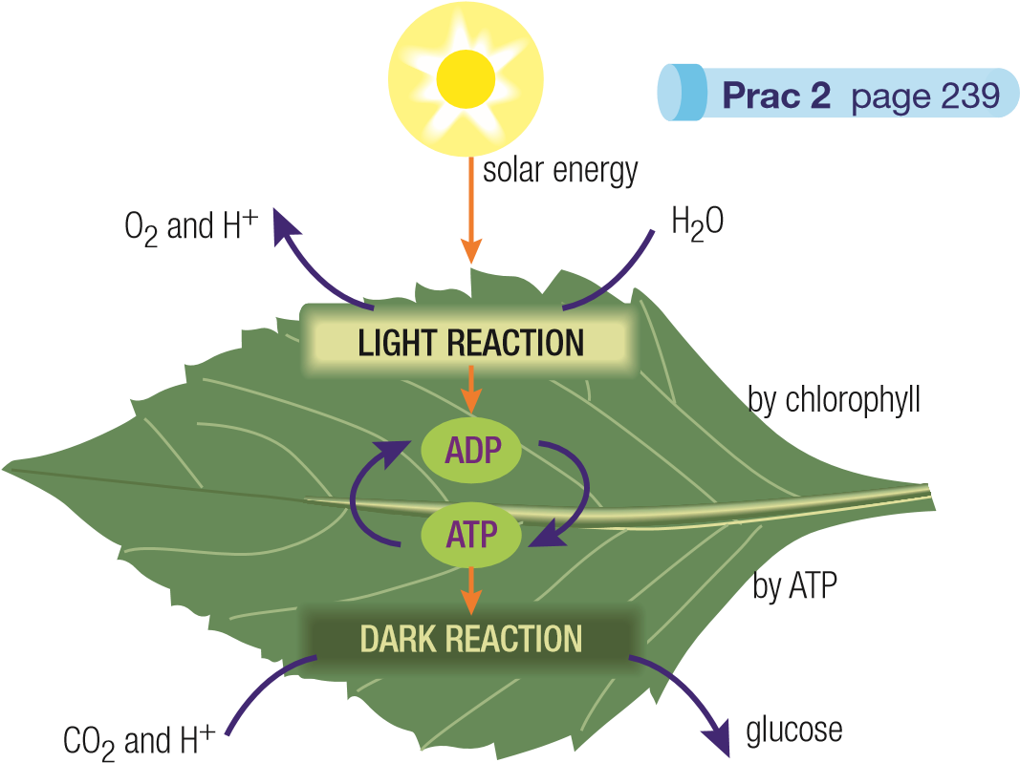
This reaction needs energy from sunlight and therefore can only happen during daylight hours. Central to this reaction are two molecules called ADP (standing for adenosine diphosphate) and ATP (adenosine triphosphate). ADP is something like a ‘flat’ battery that needs to be re-charged.
When ADP absorbs light energy it ‘charges up’ and changes into ATP. This can be written as a word equation:
ADP + energy ATP
ATP is a molecule that stores chemical energy. It acts like a charged battery, storing energy for later use in the dark reaction.
While all this is happening, enzymes split water, H2O, into oxygen, O2, and hydrogen ions, H⁺. Although this splitting normally needs temperatures of about 2000ºC, enzymes allow it to happen in the cell at room temperature.
Stage two: the dark reaction
This is a series of enzyme-controlled reactions that can proceed in the dark. It needs no energy from sunlight but it does need the energy stored in the ATP produced earlier. This energy is used to form glucose by combining carbon dioxide and hydrogen ions. As the ATP releases its energy, it changes back into ADP.
ATP ADP + energy
8.1.5 Photosynthesis occurs in two stages,

The rate of photosynthesis
The rate at which photosynthesis occurs depends on:
- the temperature
Light intensity
Rate of photosynthesis
As light intensity increases,
the rate of photosynthesis increases
Photosynthesis rate does not increase but remains constant
Carbon dioxide levels begin
to limit the rate reaction
- the amount of light available
- the availability of carbon dioxide.
If any of these factors increase, the rate of photosynthesis will generally increase too.
As in most chemical reactions, the rate of photosynthesis generally increases as the temperature gets higher. Above 30ºC, however, the enzymes no longer function properly and so the rate of photosynthesis starts to fall.
In nature, plants seldom reach their maximum rate of photosynthesis. For example, there is plenty of light on bright, sunny days but there is insufficient carbon dioxide. Likewise, the rate is limited by the cooler and darker conditions of early morning and late afternoon. At night, there is no photosynthesis because there is no sunlight to power it.

How plants use glucose
Photosynthesis produces glucose in plants which is then converted into:
- Energy via a process called respiration
- Cellulose for building plant cell walls
- other Sugars for transport to various parts of the plant
- Oils and Proteins
- Starch for temporary storage in the leaf. This happens on sunny days when photosynthesis produces glucose at a rate faster than the rate at which it is used. Photosynthesis stops at night so this stored starch is reconverted to glucose, providing continuous energy to the plant.

Revision questions

Photosynthesis makes glucose
- What do the following chemical formulae stand for: a CO2 bH2O cO2 dC6H12O6?
- Write the balanced chemical equation that summarises photosynthesis.
- What provides the energy needed for photosynthesis to occur?

Chlorophyll and chloroplasts
4 What is chlorophyll, where is it found and what is its role in photosynthesis?

Photosynthesis in more detail
- Photosynthesis does not occur when chlorophyll, water and carbon dioxide are placed in a test tube in sunlight. Why?
Light intensity
Oxygen produced
y
x
The rate of photosynthesis
6 Most chemical reactions keep getting faster as the
temperature increases but photosynthesis doesn’t.
Explain why.

7 Explain the conditions that may have produced the lines shown on the graph below.

How plants use glucose
- State five ways in which the glucose formed during photosynthesis can be used by the plant. Thinking questions
9 An experiment was conducted using the flasks shown below.
All flasks contained water, were at the same temperature and were in sunlight. After 2 hours, the carbon dioxide and oxygen levels in each fl ask were measured.
- In which flask or flasks would photosynthesis be occurring?

- In which flask or flasks would respiration be occurring?

- After the 2 hours which flask would have the highest carbon dioxide level? Why?

- After the 2 hours which flask would have the highest oxygen level? Why?

